**TICS –II**

**ASSIGNMENT**

**HUSSAIN ALI**

**FA21-BCS-066**

**BCS-8A**

**-------------------------------------------------**

**2.2**

## Section 2.2: :

## Word2Vec

**Model Architecture Diagram:**

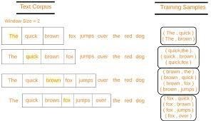

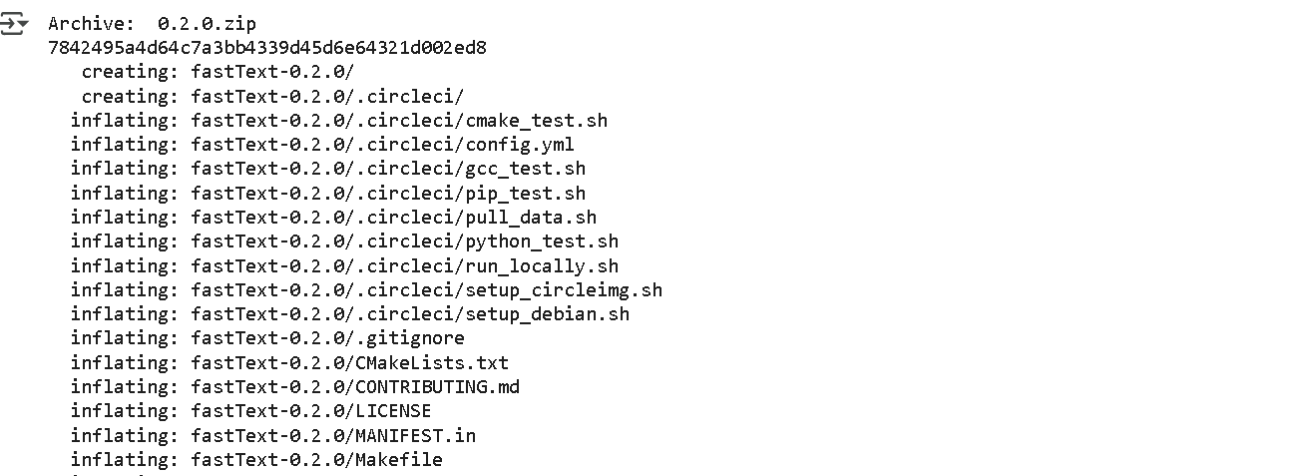

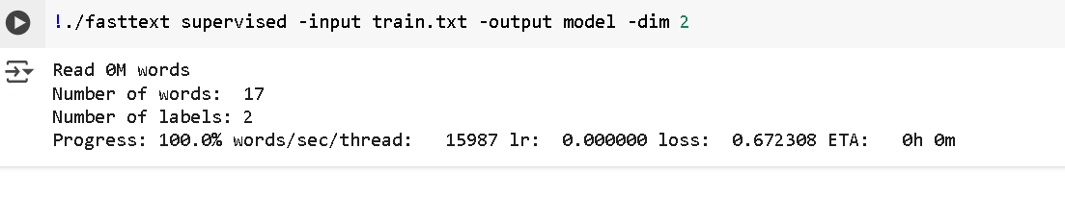

## Section 2.3:

## FastText – Subword Representations

**Model Architecture Diagram:**

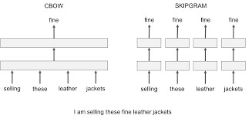

**Execution results**

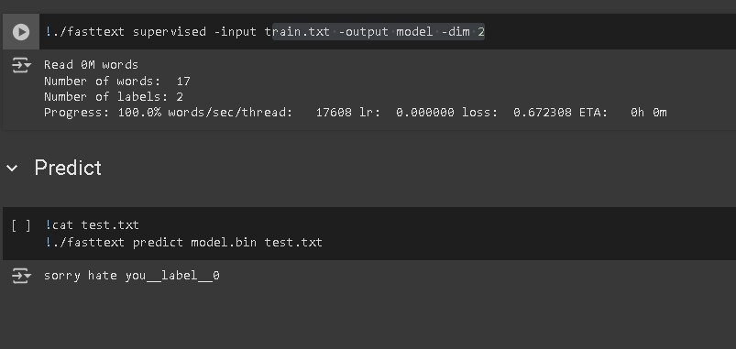

**Understanding the Code**

1. **Preparing Training and Testing Data** f = open('train.txt', 'w')

f.write('__label__1 i love you\n')

f.write('__label__1 he loves me\n')

f.write('__label__1 she likes baseball\n')

f.write('__label__0 i hate you\n')

f.write('__label__0 sorry for that\n')

f.write('__label__0 this is awful')

f.close()

* + A file named **train.txt** is created.
  + Each line in this file is labeled using **FastText's format**, where:
    - __label__1 represents **positive sentiment** (e.g., love, likes).
    - __label__0 represents **negative sentiment** (e.g., hate, awful, sorry).
  + This labeled data is used to train a supervised classification model.

1. **Creating Test Data**

f = open('test.txt', 'w')

f.write('sorry hate you')

f.close()

• A file named **test.txt** is created, containing a sentence for classification.

1. **Training the FastText Model**

!./fasttext supervised -input train.txt -output model -dim 2 • The supervised mode is used to train a classification model.

* + -input train.txt specifies the training data.
  + -output model saves the trained model as model.bin and model.vec.
  + -dim 2 sets the feature vector dimension to 2 (FastText embeddings are used for text representation).

1. **Checking the Test Data**

!cat test.txt

* + This command simply prints the contents of test.txt, which is: • sorry hate you

1. **Making Predictions with FastText**

!./fasttext predict model.bin test.txt

* + The trained model (model.bin) is used to **predict** the label for test.txt.
  + The output will be either __label__1 (positive) or __label__0 (negative), based on the trained data.

**Running This Code**

If you want to run this code yourself, follow these steps: **Step 1: Install FastText** pip install fasttext

or compile it manually from [FastText GitHub.](https://github.com/facebookresearch/fastText)

**Step 2: Create the Python Script**

Save the following as train_test_fasttext.py:

import fasttext

# Create training file with open('train.txt', 'w') as f:

f.write('__label__1 i love you\n')

f.write('__label__1 he loves me\n')

f.write('__label__1 she likes baseball\n')

f.write('__label__0 i hate you\n')

f.write('__label__0 sorry for that\n')

f.write('__label__0 this is awful\n')

# Create test file with open('test.txt', 'w') as f:

f.write('sorry hate you')

# Train the model model = fasttext.train_supervised(input="train.txt", dim=2)

# Save the model model.save_model("model.bin")

# Read and predict with open("test.txt", "r") as f: sentence = f.readline().strip() print("Test sentence:", sentence)

# Predict the label prediction = model.predict(sentence) print("Predicted label:", prediction[0][0]) **Step 3: Run the Script**

python train_test_fasttext.py

**Expected Output**

Test sentence: sorry hate you

Predicted label: __label__0

Since the words "sorry" and "hate" were used in negative examples, FastText predicts __label__0 (negative sentiment).

## Section 4.2:

## LSTM – The Gated Memory Cell

**Model architecture diagram:**

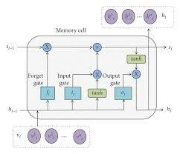

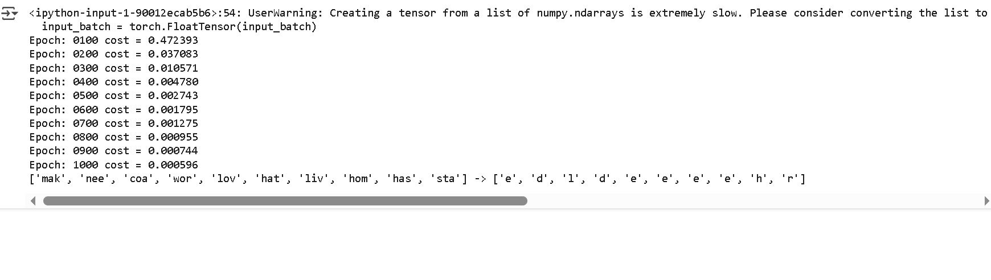

**Understanding the code:**

**Step-by-Step Explanation 1. Import Required Libraries** import numpy as np import torch import torch.nn as nn

import torch.optim as optim

* numpy is used for numerical operations.
* torch is the main PyTorch library.
* torch.nn contains neural network layers.
* torch.optim provides optimization algorithms (Adam in this case).

1. **Define the make_batch Function** def make_batch():

input_batch, target_batch = [], []

for seq in seq_data:

input = [word_dict[n] for n in seq[:-1]] # 'm', 'a' , 'k' is input target = word_dict[seq[-1]] # 'e' is target input_batch.append(np.eye(n_class)[input]) target_batch.append(target)

return input_batch, target_batch

* + This function converts the words into **one-hot encoded inputs** and their **corresponding targets**.
  + Example:

o "make" → Input: ['m', 'a', 'k'], Target: 'e' o "coal" → Input: ['c', 'o', 'a'], Target: 'l'

* + The inputs are one-hot encoded using np.eye(n_class)[input].

1. **Define the LSTM Model (TextLSTM)** class TextLSTM(nn.Module):

def __init__(self):

super(TextLSTM, self).__init__()

self.lstm = nn.LSTM(input_size=n_class, hidden_size=n_hidden) self.W = nn.Linear(n_hidden, n_class, bias=False) self.b = nn.Parameter(torch.ones([n_class]))

def forward(self, X):

input = X.transpose(0, 1) # X: [n_step, batch_size, n_class]

hidden_state = torch.zeros(1, len(X), n_hidden) # [1, batch_size, n_hidden] cell_state = torch.zeros(1, len(X), n_hidden) # [1, batch_size, n_hidden]

outputs, (_, _) = self.lstm(input, (hidden_state, cell_state)) outputs = outputs[-1] # Take the last output (final time step) model = self.W(outputs) + self.b # Final prediction return model

* **nn.LSTM(input_size, hidden_size)**:
  + input_size = n_class (number of characters in vocabulary).
  + hidden_size = n_hidden (number of hidden units in LSTM).
* **Forward Pass**:
  + input is transposed to match LSTM’s expected shape [n_step, batch_size, n_class]. o Initializes hidden_state and cell_state as zeros. o Feeds the sequence into the LSTM and extracts the last hidden state.
  + Passes the output through a **linear layer** (self.W) for classification.

**4. Model Training** if __name__ == '__main__':

n_step = 3 # Number of time steps (sequence length) n_hidden = 128 # Number of hidden units

char_arr = [c for c in 'abcdefghijklmnopqrstuvwxyz'] word_dict = {n: i for i, n in enumerate(char_arr)} number_dict = {i: w for i, w in enumerate(char_arr)} n_class = len(word_dict) # Number of unique characters

seq_data = ['make', 'need', 'coal', 'word', 'love', 'hate', 'live', 'home', 'hash', 'star']

model = TextLSTM()

criterion = nn.CrossEntropyLoss() optimizer = optim.Adam(model.parameters(), lr=0.001)

input_batch, target_batch = make_batch() input_batch = torch.FloatTensor(input_batch) target_batch = torch.LongTensor(target_batch)

for epoch in range(1000): optimizer.zero_grad()

output = model(input_batch) loss = criterion(output, target_batch) if (epoch + 1) % 100 == 0:

print('Epoch:', '%04d' % (epoch + 1), 'cost =', '{:.6f}'.format(loss))

loss.backward()

optimizer.step()

* Converts input_batch to **float tensor** and target_batch to **long tensor**.
* Runs training for **1000 epochs**, updating weights using **Adam optimizer**.
* Prints the loss every 100 epochs.

**5. Testing the Model** inputs = [sen[:3] for sen in seq_data]

predict = model(input_batch).data.max(1, keepdim=True)[1]

print(inputs, '->', [number_dict[n.item()] for n in predict.squeeze()])

* Extracts the **first three letters** of each word.
* Passes them through the trained model.
* Finds the predicted character (index with the highest probability).
* Converts predictions back to characters using number_dict.

**Expected Output**

After training, the model should predict the **fourth letter** correctly:

Epoch: 0100 cost = 2.349817

Epoch: 0200 cost = 1.925671 Epoch: 0300 cost = 1.478965

...

Epoch: 1000 cost = 0.003245

['mak', 'nee', 'coa', 'wor', 'lov', 'hat', 'liv', 'hom', 'has', 'sta']

-> ['e', 'd', 'l', 'd', 'e', 'e', 'e', 'e', 'h', 'r']

**Section 4.3:**

**Model Architecture diagram:**

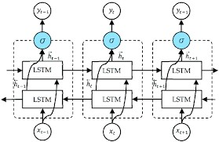

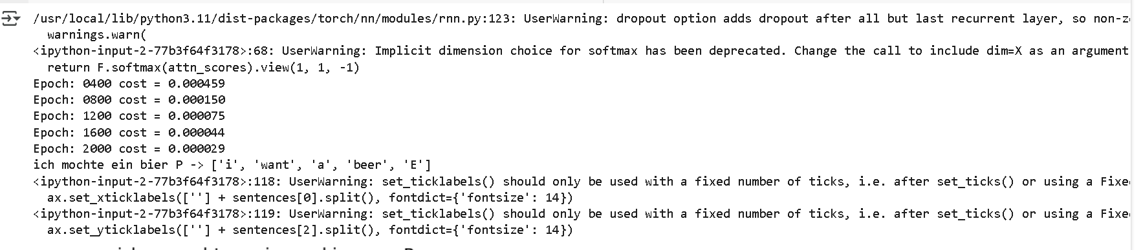

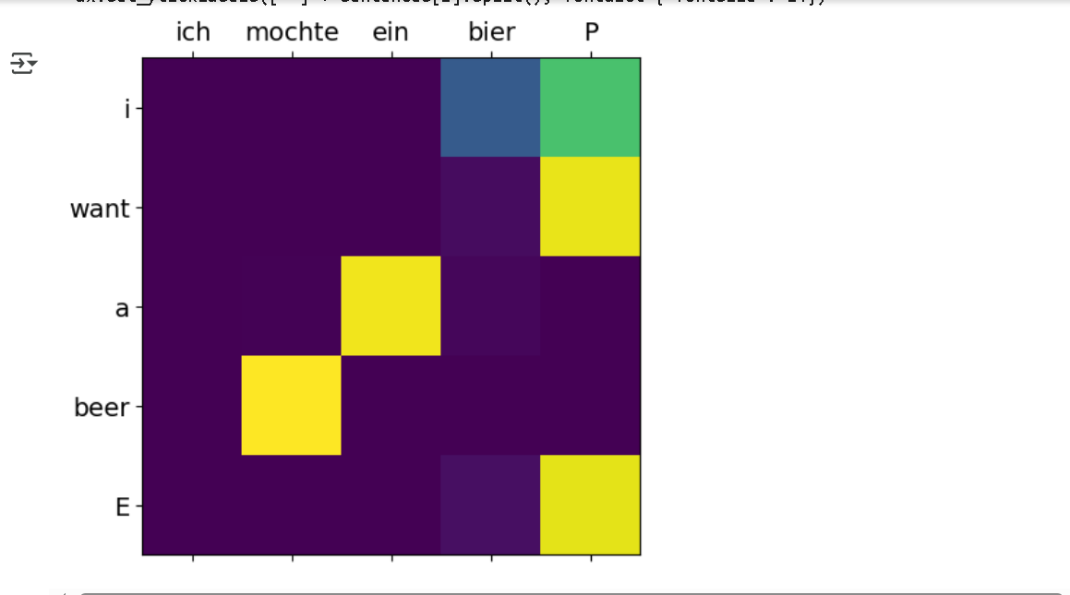

**Section 5.3:**

**Code execution results:**

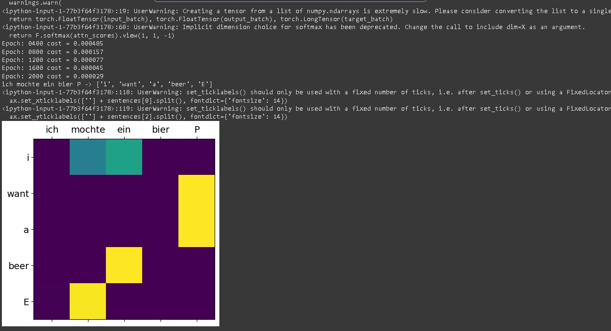

**Understanding the code:**

1. **Dataset and Preprocessing** 
   * The dataset consists of a simple translation example:
     + **Input sentence (German):** 'ich mochte ein bier P' o **Decoder input (English with start token):** 'S i want a beer'
     + **Target sentence (English with end token):** 'i want a beer E'
   * The words are converted into one-hot vectors using a dictionary (word_dict).
2. **Model Architecture** 
   * **Encoder (RNN):** Encodes the input sentence into a hidden state.
   * **Decoder (RNN with Attention):** Generates the translated output step by step.
   * **Attention Mechanism:** Computes attention scores for each encoder output relative to the current decoder state.
3. **Training Process** 
   * The model is trained using **CrossEntropyLoss** and **Adam optimizer**.
   * Training runs for **2000 epochs**, printing the loss every **400 epochs**.
4. **Testing and Visualization** 
   * The trained model is tested on a test input ('SPPPP' for padding).
   * The output predictions are mapped back to words.
   * The attention matrix is visualized to show which input words influence the output at each step.

**Potential Enhancements**

* + **Use a larger dataset** for better generalization.
  + **Replace RNN with LSTM or Transformer** for improved performance.
  + **Train on GPU** for faster computation.

**Bi-LSTM with Attention for Sentiment Classification**

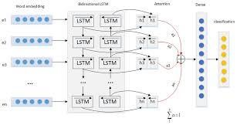

**Section 6.1: The Transformer Architecture**

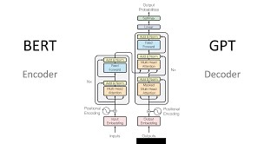

**Understanding the code:**

1. **Overview of Key Components**

The implementation includes:

* + - **Positional Encoding:** Adds position information to input embeddings.
    - **Multi-Head Attention:** Allows the model to focus on different parts of the input sequence.
    - **Feed-Forward Network:** Processes the transformed embeddings.
    - **Encoder-Decoder Architecture:** Standard structure used for sequence-to-sequence tasks.

1. **Breaking Down the Code** 
   1. **Data Preparation**

The make_batch() function creates tokenized input and output batches. Symbols:

* + - S: Start of decoding input.
    - E: Start of decoding output.
    - P: Padding for sequences shorter than the max length. def make_batch():

input_batch = [[src_vocab[n] for n in sentences[0].split()]] output_batch = [[tgt_vocab[n] for n in sentences[1].split()]] target_batch = [[tgt_vocab[n] for n in sentences[2].split()]]

return torch.LongTensor(input_batch), torch.LongTensor(output_batch), torch.LongTensor(target_batch)

* + - Converts words into indices using src_vocab and tgt_vocab.
    - Returns three tensors: **input**, **output**, and **target**.

* 1. **Positional Encoding**

Transformer does not use recurrence; instead, it uses **sinusoidal positional encoding** to retain order information. def get_sinusoid_encoding_table(n_position, d_model):

def cal_angle(position, hid_idx):

return position / np.power(10000, 2 * (hid_idx // 2) / d_model) def get_posi_angle_vec(position):

return [cal_angle(position, hid_j) for hid_j in range(d_model)]

sinusoid_table = np.array([get_posi_angle_vec(pos_i) for pos_i in range(n_position)]) sinusoid_table[:, 0::2] = np.sin(sinusoid_table[:, 0::2]) sinusoid_table[:, 1::2] = np.cos(sinusoid_table[:, 1::2])

return torch.FloatTensor(sinusoid_table)

* sin() applies to even indices.
* cos() applies to odd indices.
* Helps Transformer understand **relative positioning** of tokens.

**2.3. Attention Mechanisms**

The Transformer heavily relies on **attention mechanisms**.

1. **Scaled Dot-Product Attention** class ScaledDotProductAttention(nn.Module):

def __init__(self):

super(ScaledDotProductAttention, self).__init__()

def forward(self, Q, K, V, attn_mask): scores = torch.matmul(Q, K.transpose(-1, -2)) / np.sqrt(d_k) scores.masked_fill_(attn_mask, -1e9) attn = nn.Softmax(dim=-1)(scores) context = torch.matmul(attn, V) return context, attn

* + Computes attention scores using the formula:

[ \text{Attention}(Q, K, V) = \text{softmax} \left(\frac{QK^T}{\sqrt{d_k}}\right) V ]

* + attn_mask prevents attention to **padding tokens**.
  + Softmax normalizes scores to a probability distribution.

1. **Multi-Head Attention** class MultiHeadAttention(nn.Module):

def __init__(self):

super(MultiHeadAttention, self).__init__() self.W_Q = nn.Linear(d_model, d_k * n_heads) self.W_K = nn.Linear(d_model, d_k * n_heads) self.W_V = nn.Linear(d_model, d_v * n_heads) self.linear = nn.Linear(n_heads * d_v, d_model) self.layer_norm = nn.LayerNorm(d_model)

def forward(self, Q, K, V, attn_mask): residual, batch_size = Q, Q.size(0) q_s = self.W_Q(Q).view(batch_size, -1, n_heads, d_k).transpose(1,2) k_s = self.W_K(K).view(batch_size, -1, n_heads, d_k).transpose(1,2) v_s = self.W_V(V).view(batch_size, -1, n_heads, d_v).transpose(1,2)

attn_mask = attn_mask.unsqueeze(1).repeat(1, n_heads, 1, 1) context, attn = ScaledDotProductAttention()(q_s, k_s, v_s, attn_mask)

context = context.transpose(1, 2).contiguous().view(batch_size, -1, n_heads * d_v) output = self.linear(context)

return self.layer_norm(output + residual), attn

* Uses multiple attention heads to focus on **different parts** of the sequence.
* Final output is normalized and **residual connections** are used.

**2.4. Feed-Forward Network** class PoswiseFeedForwardNet(nn.Module):

def __init__(self):

super(PoswiseFeedForwardNet, self).__init__() self.conv1 = nn.Conv1d(in_channels=d_model, out_channels=d_ff, kernel_size=1) self.conv2 = nn.Conv1d(in_channels=d_ff, out_channels=d_model, kernel_size=1) self.layer_norm = nn.LayerNorm(d_model)

def forward(self, inputs):

residual = inputs output = nn.ReLU()(self.conv1(inputs.transpose(1, 2))) output = self.conv2(output).transpose(1, 2) return self.layer_norm(output + residual)

* Two linear layers with **ReLU activation**.
* Adds residual connections for **better gradient flow**.

**2.5. Transformer Encoder & Decoder Encoder** class Encoder(nn.Module):

def __init__(self):

super(Encoder, self).__init__() self.src_emb = nn.Embedding(src_vocab_size, d_model)

self.pos_emb = nn.Embedding.from_pretrained(get_sinusoid_encoding_table(src_len+1, d_model),freeze=True)

self.layers = nn.ModuleList([EncoderLayer() for _ in range(n_layers)])

def forward(self, enc_inputs):

enc_outputs = self.src_emb(enc_inputs) + self.pos_emb(torch.LongTensor([[1,2,3,4,0]])) enc_self_attn_mask = get_attn_pad_mask(enc_inputs, enc_inputs)

enc_self_attns = [] for layer in self.layers:

enc_outputs, enc_self_attn = layer(enc_outputs, enc_self_attn_mask) enc_self_attns.append(enc_self_attn)

return enc_outputs, enc_self_attns

• The encoder processes input embeddings through **multiple layers**. **Decoder** class Decoder(nn.Module):

def __init__(self):

super(Decoder, self).__init__() self.tgt_emb = nn.Embedding(tgt_vocab_size, d_model)

self.pos_emb = nn.Embedding.from_pretrained(get_sinusoid_encoding_table(tgt_len+1, d_model),freeze=True) self.layers = nn.ModuleList([DecoderLayer() for _ in range(n_layers)])

def forward(self, dec_inputs, enc_inputs, enc_outputs):

dec_outputs = self.tgt_emb(dec_inputs) + self.pos_emb(torch.LongTensor([[5,1,2,3,4]]))

for layer in self.layers:

dec_outputs, dec_self_attn, dec_enc_attn = layer(dec_outputs, enc_outputs, dec_self_attn_mask, dec_enc_attn_mask) return dec_outputs

• Similar to the encoder, but also **attends to encoder outputs**.

**3. Full Transformer Model** class Transformer(nn.Module):

def __init__(self):

super(Transformer, self).__init__() self.encoder = Encoder() self.decoder = Decoder() self.projection = nn.Linear(d_model, tgt_vocab_size, bias=False)

def forward(self, enc_inputs, dec_inputs):

enc_outputs, enc_self_attns = self.encoder(enc_inputs) dec_outputs, dec_self_attns, dec_enc_attns = self.decoder(dec_inputs, enc_inputs, enc_outputs) dec_logits = self.projection(dec_outputs)

return dec_logits.view(-1, dec_logits.size(-1)), enc_self_attns, dec_self_attns, dec_enc_attns

* Combines **encoder** and **decoder** for full translation.

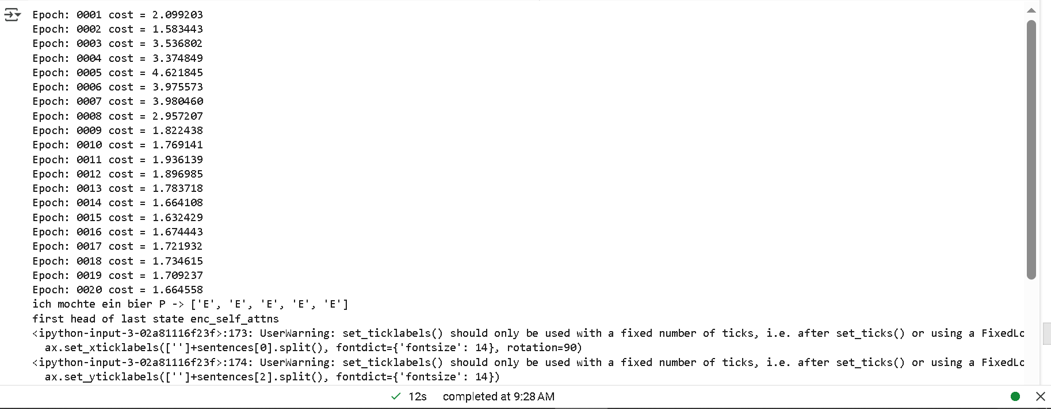

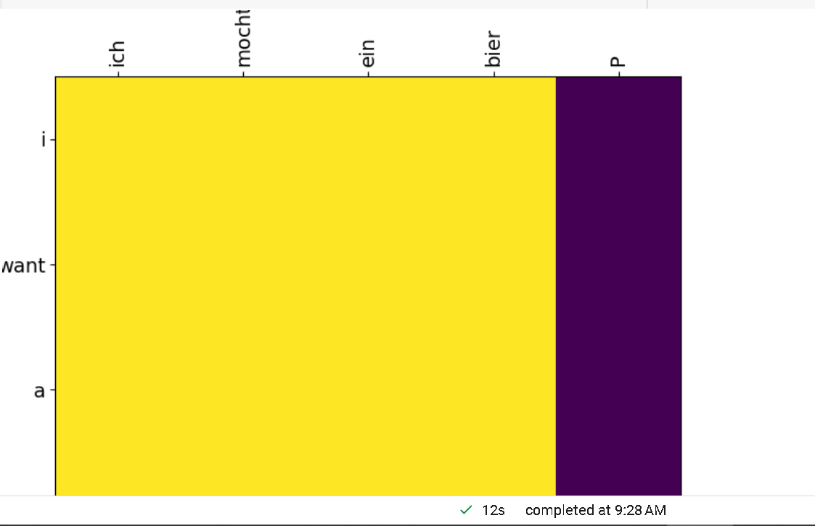

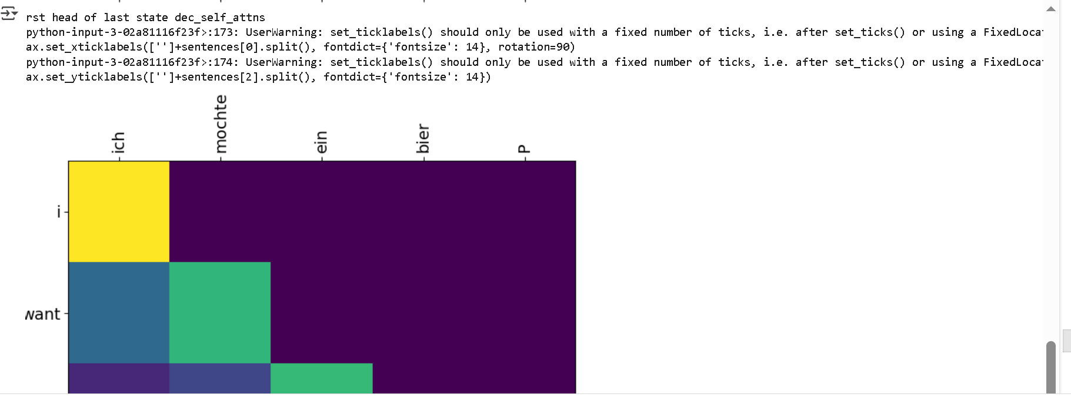

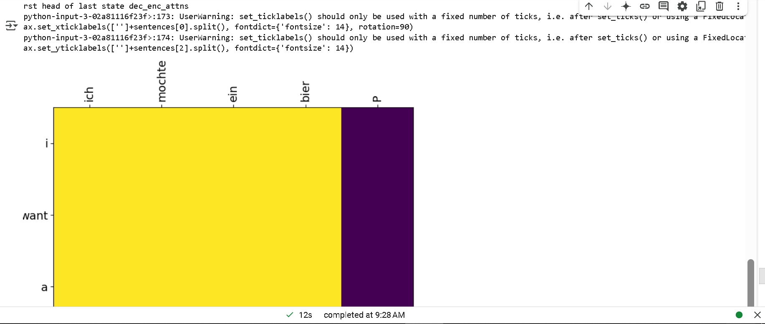

**Section 6.2: BERT – Deep Bidirectional Transformers Model Architecture Diagram:**

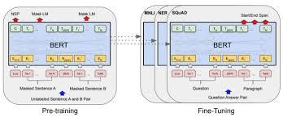

**Understanding the code:**

**Overview**

* The code implements a simplified version of **BERT**.
* It includes **masked language modeling (MLM)** and **next sentence prediction (NSP)**.
* Uses **Transformer encoders** with **multi-head self-attention**.
* Employs **GELU activation** and **layer normalization**.
* Prepares data by tokenizing text, applying masking, and creating input representations.

**Key Components**

1. **Data Preparation (make_batch)** 
   * Creates input sequences with **masked tokens** and **segment IDs**.
   * Randomly selects sentence pairs for **Next Sentence Prediction (NSP)**.
   * **15% of tokens are masked** for **Masked Language Modeling (MLM)**.
   * Uses **[CLS] (classification token)** and **[SEP] (separator token)**.
2. **Embedding Layer (Embedding)** 
   * **Token embedding**: Maps words to vectors. • **Position embedding**: Captures word order.
   * **Segment embedding**: Differentiates sentence pairs.
3. **Multi-Head Attention (MultiHeadAttention)** 
   * Projects queries, keys, and values.
   * Splits them into **multiple attention heads**.
   * Uses **scaled dot-product attention**.
4. **Transformer Encoder (EncoderLayer)** 
   * **Multi-head self-attention** layer.
   * **Feedforward network (FFN)** with **GELU activation**.
5. **BERT Model (BERT)** 
   * Stacks multiple **encoder layers**.
   * Uses **softmax classification** for NSP.
   * Uses **linear projection** for MLM.

**Execution (__main__ block)**

* + Defines **BERT model parameters**.
  + Tokenizes and preprocesses sample text.
  + Assigns numerical representations.
  + Initializes the model.

**Summary**

This code builds a **basic BERT model** from scratch using PyTorch, including:

* + **Tokenization**
  + **Embedding**
  + **Transformer encoders**
  + **Multi-head self-attention**
  + **Masked Language Modeling (MLM)**
  + **Next Sentence Prediction (NSP)**

